INTERNSHIP TASK SUBMISSION
Product Catalog Management API
Testing & Output Evidence Report

Task 2 — RESTful API Development & Testing
Submitted by: Rabail Noureen
Internship Program: Syntecxhub

Task 2 Overview
Task 2 required the design, development, and testing of a RESTful “Product Catalog Management API” capable of handling the complete lifecycle of a product catalog for an e-commerce style application. The API was built to support secure user authentication, full CRUD (Create, Read, Update, Delete) operations on product records, advanced querying through search, category, and price-range filters, server-side pagination, and a dedicated analytics endpoint that summarizes catalog data using MongoDB aggregation.
All endpoints were implemented following REST conventions and were thoroughly tested using Postman. Every request and its corresponding response — including success cases, validation failures, and unauthorized-access scenarios — was captured as evidence and is documented in the API Testing section of this report.

Technologies Used
- Node.js — server-side JavaScript runtime powering the API
- Express.js — web framework used to define REST routes and middleware
- MongoDB — NoSQL database used to persist product and user data
- Mongoose — ODM used for schema definition, validation, and querying
- JWT (JSON Web Token) — token-based authentication and route protection
- Postman — API client used to execute and document all test requests
- MongoDB Aggregation Framework — used to compute catalog analytics

API Testing — Evidence & Explanation

1. Login Authentication
POST /api/auth/login
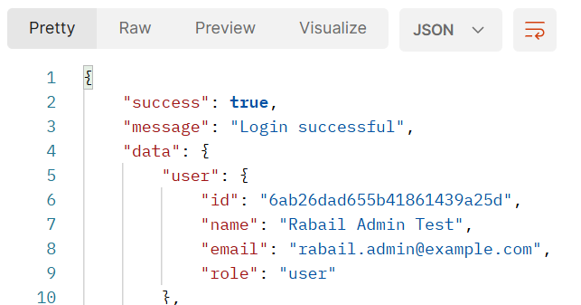
The login endpoint was tested with valid user credentials. The API responded with a success flag, a confirmation message, and the authenticated user’s profile details (ID, name, email, and role), confirming that credential verification and session/token issuance are working as expected.

2. Product Creation
POST /api/products
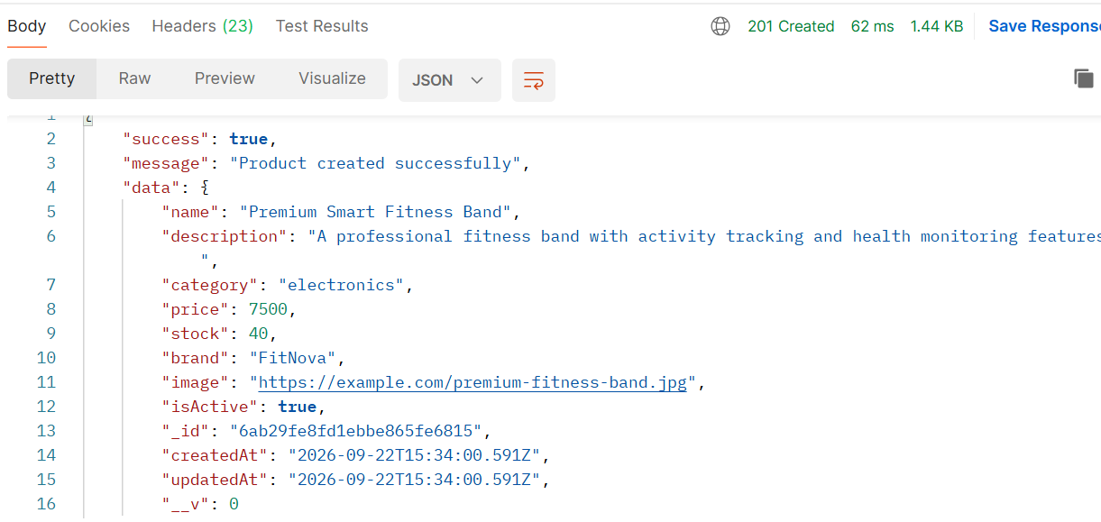
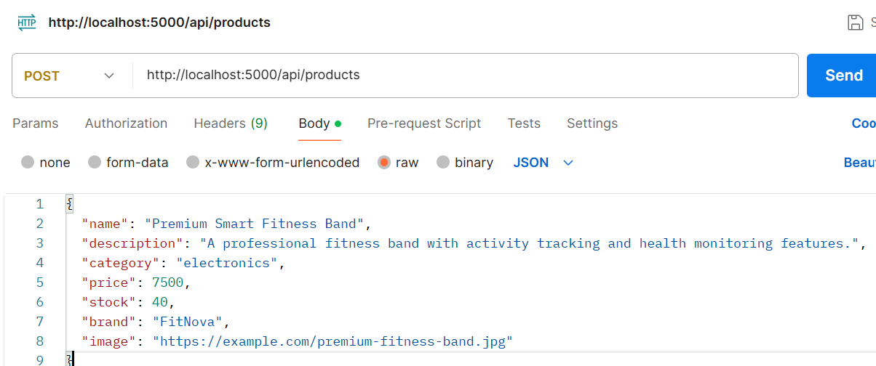
A new product (“Premium Smart Fitness Band”) was created by sending a JSON payload containing the name, description, category, price, stock, brand, and image URL. The API returned a 201 Created status along with the newly generated product document, including its MongoDB-assigned _id and createdAt/updatedAt timestamps, confirming that the record was persisted correctly.

3. Get All Products
GET /api/products
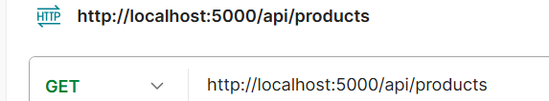
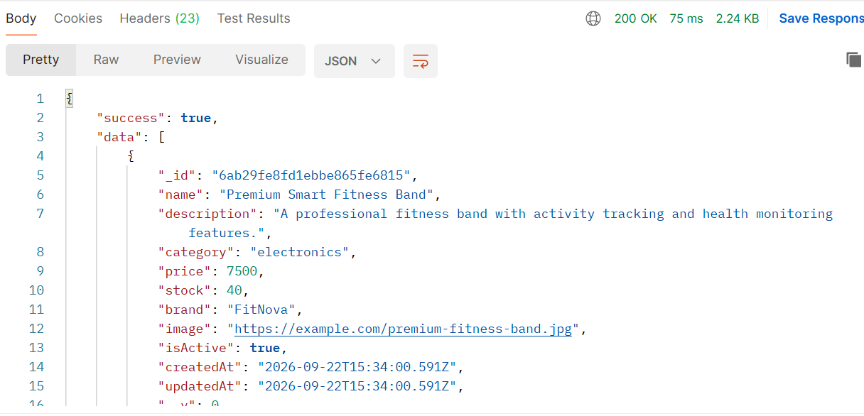
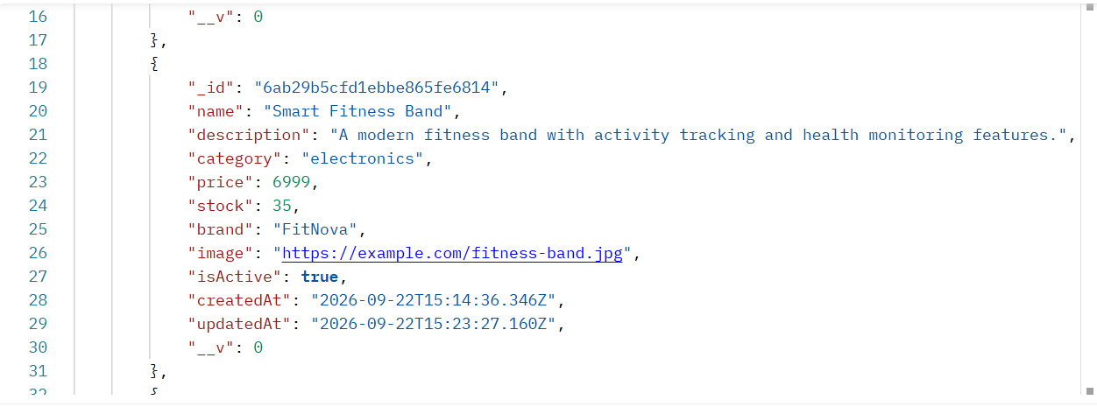
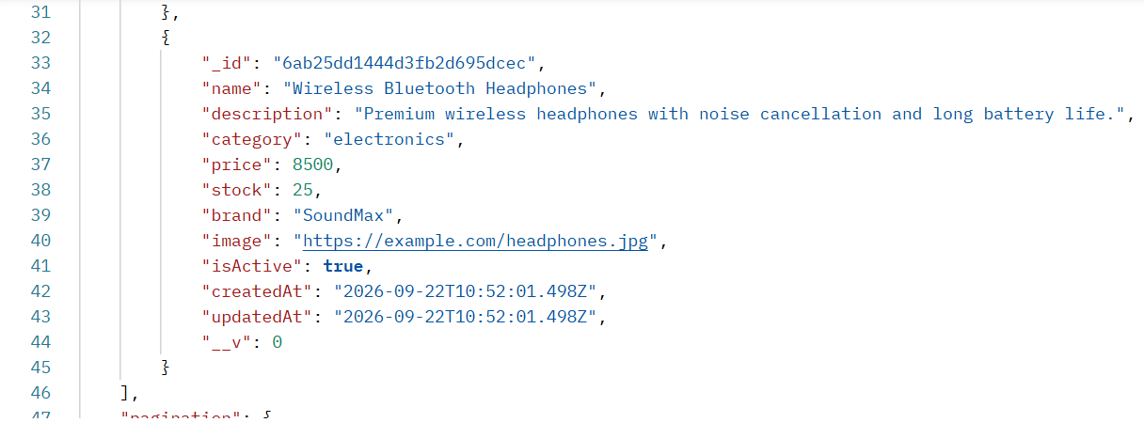
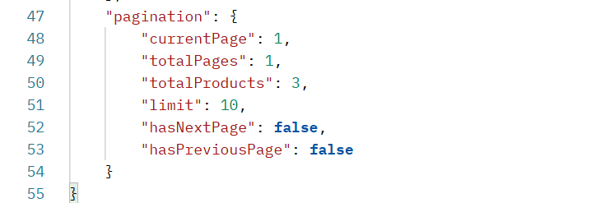
This endpoint retrieves the complete product catalog. The response returned a 200 OK status with an array of all stored products along with a pagination object (current page, total pages, total product count, and page limit), verifying that listing and pagination logic function correctly.

4. Search by Product Name
GET /api/products?search=fitness
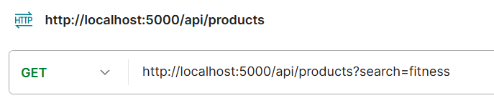
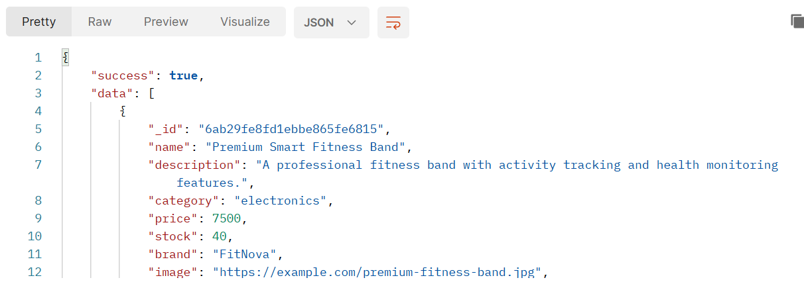
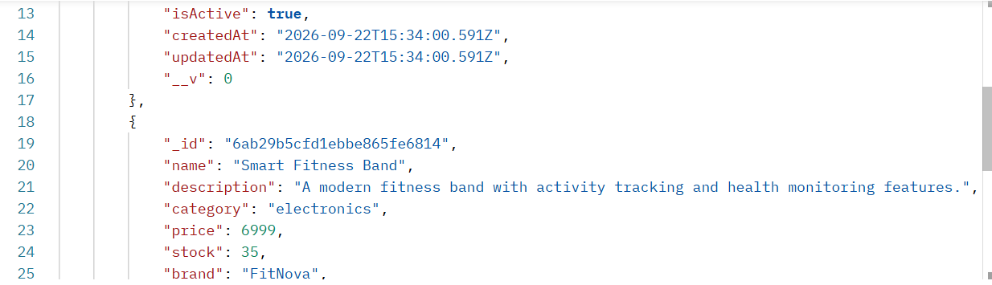
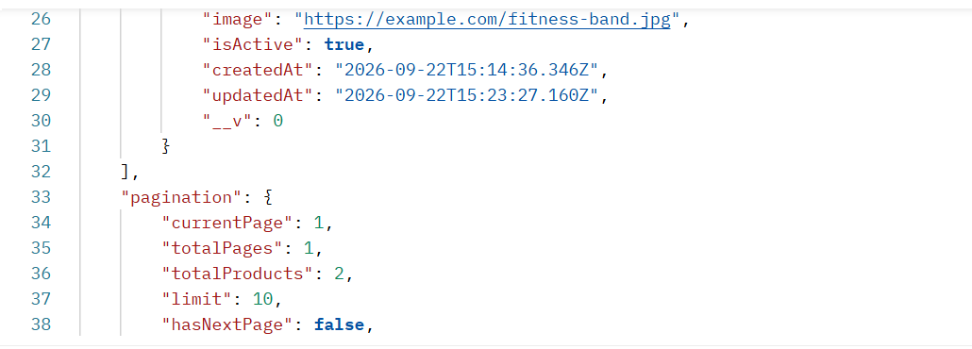
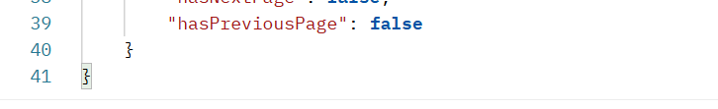
The search functionality was tested using the keyword “fitness.” The API correctly returned only the two matching products (“Premium Smart Fitness Band” and “Smart Fitness Band”) along with an updated pagination summary, confirming that the search query performs accurate, case-insensitive text matching on the product name.

5. Category Filter
GET /api/products?category=electronics
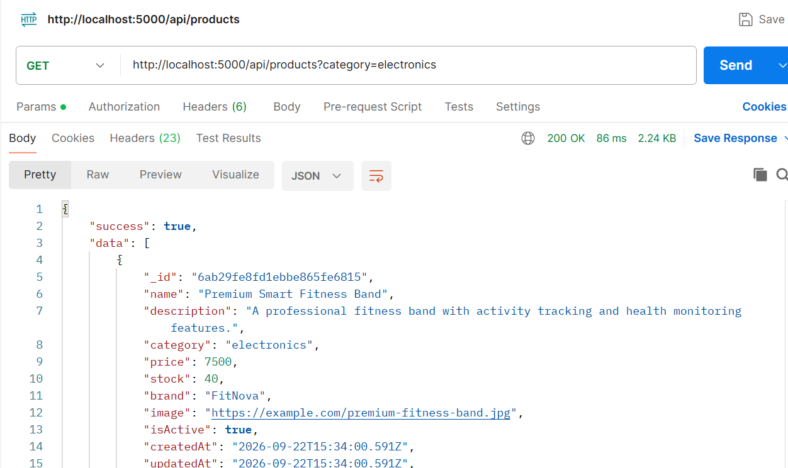
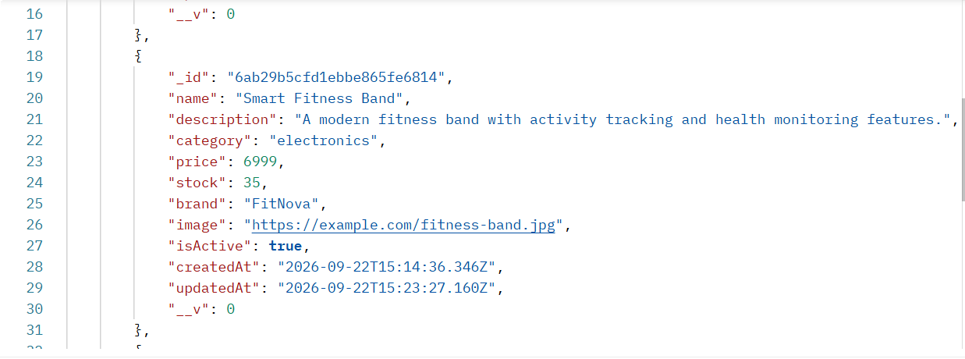
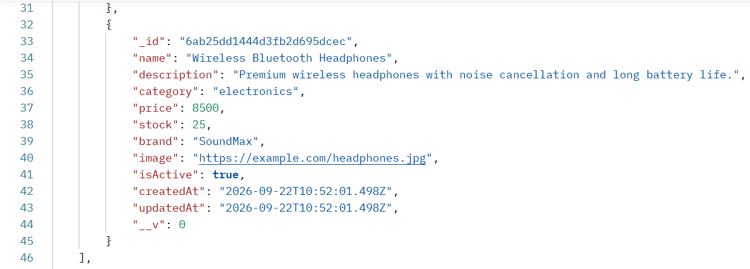
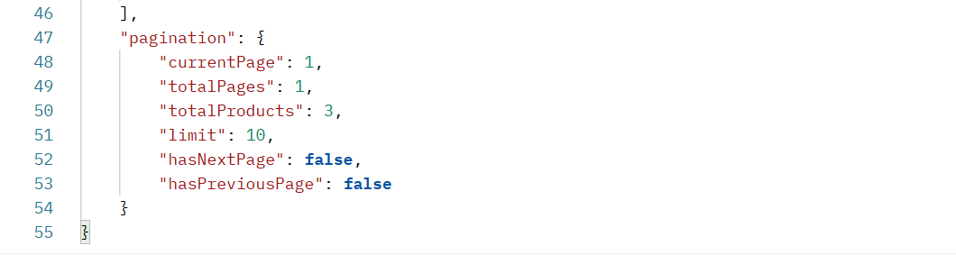
Filtering by category (“electronics”) returned all products belonging to that category with a 200 OK response and correct pagination metadata, demonstrating that category-based filtering is implemented and functioning as intended.

6. Price Filter
GET /api/products?minPrice=6000&maxPrice=7000
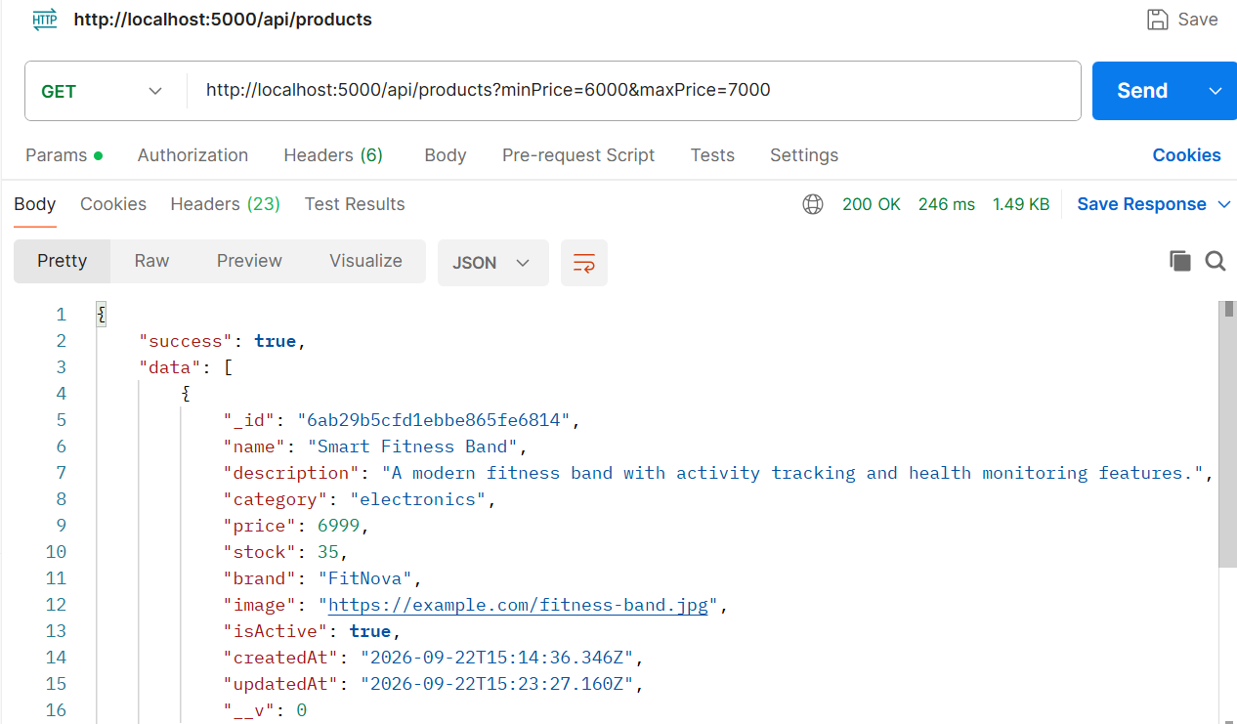
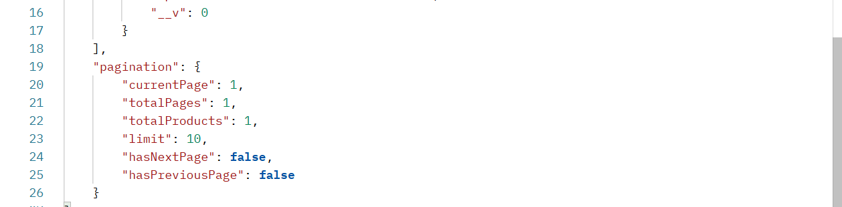
A price-range filter was applied to retrieve products priced between 6000 and 7000. The API returned only the matching product (“Smart Fitness Band”, priced at 6999), confirming that the minPrice/maxPrice query parameters are correctly translated into range-based database queries.

7. Update Product
PUT /api/products/:id
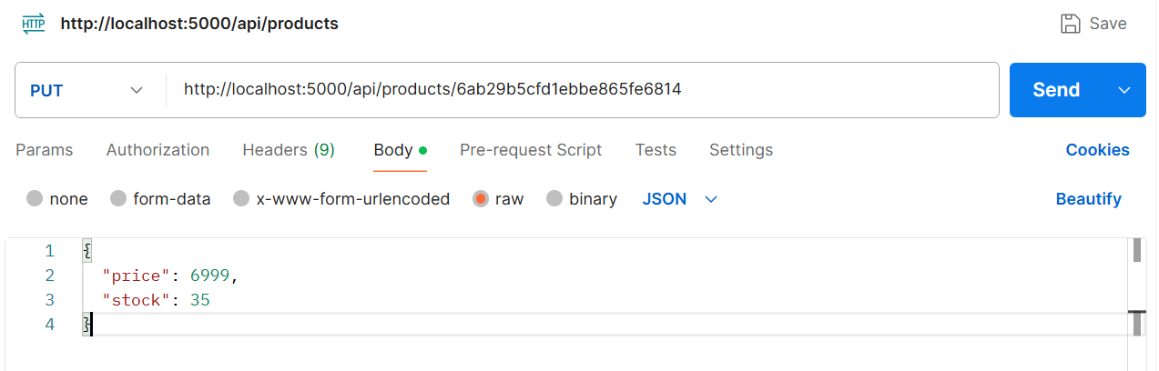
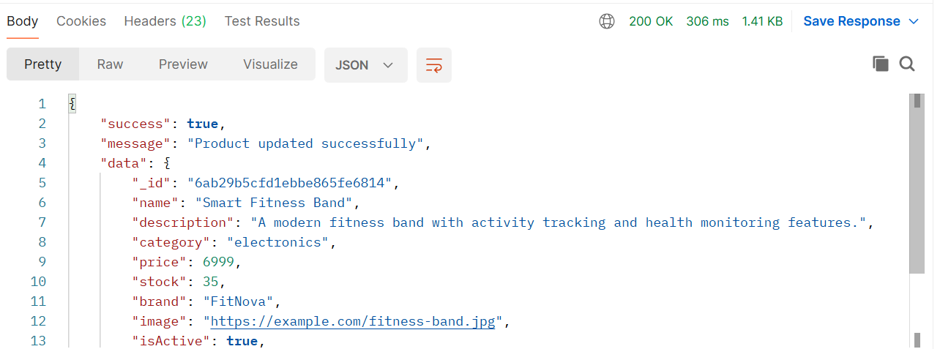
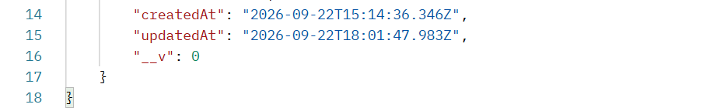
An existing product was updated by sending a partial payload containing only the fields to be changed (price and stock). The API responded with a 200 OK status, a confirmation message, and the updated product document, verifying that partial updates are applied correctly without affecting the remaining fields.

8. Product Analytics
GET /api/products/analytics
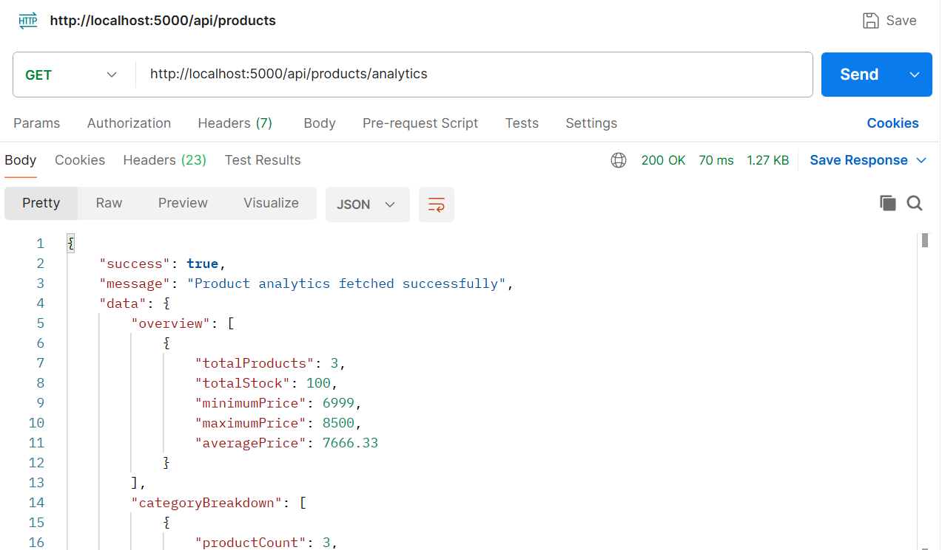
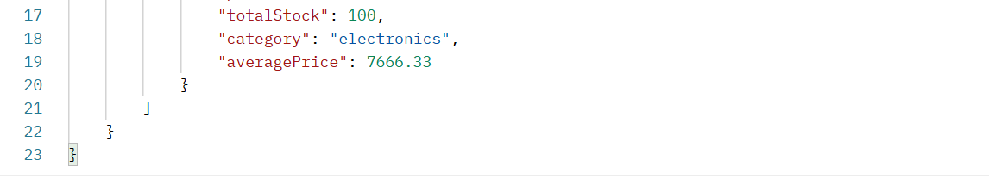
The analytics endpoint returns aggregated catalog statistics rather than raw product records. The response included an overview (total products, total stock, minimum price, maximum price, and average price) and a category-wise breakdown, confirming that the aggregation logic correctly summarizes data across the entire collection.

9. Validation / Error Handling
POST /api/products (invalid payload)
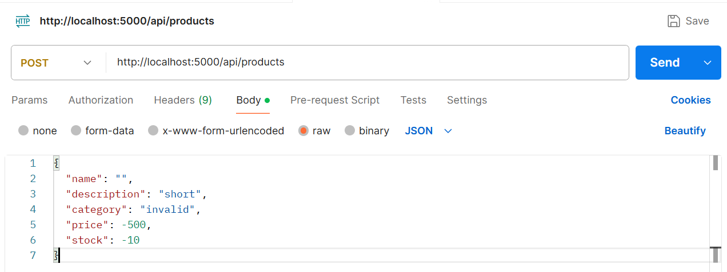
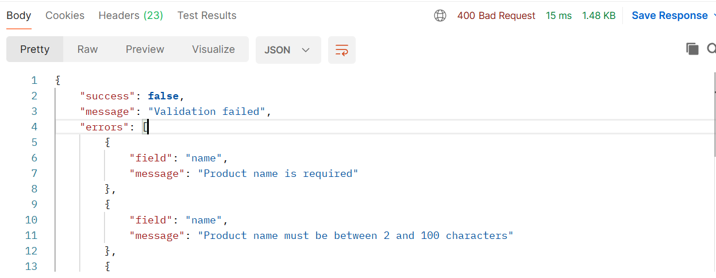
An intentionally invalid payload (empty name, an overly short description, an invalid category, a negative price, and negative stock) was submitted to test input validation. The API rejected the request with a 400 Bad Request status and returned a structured list of field-level error messages, confirming that server-side validation correctly enforces the required data rules before any record is created.

10. Unauthorized Access
POST /api/products (no auth token)
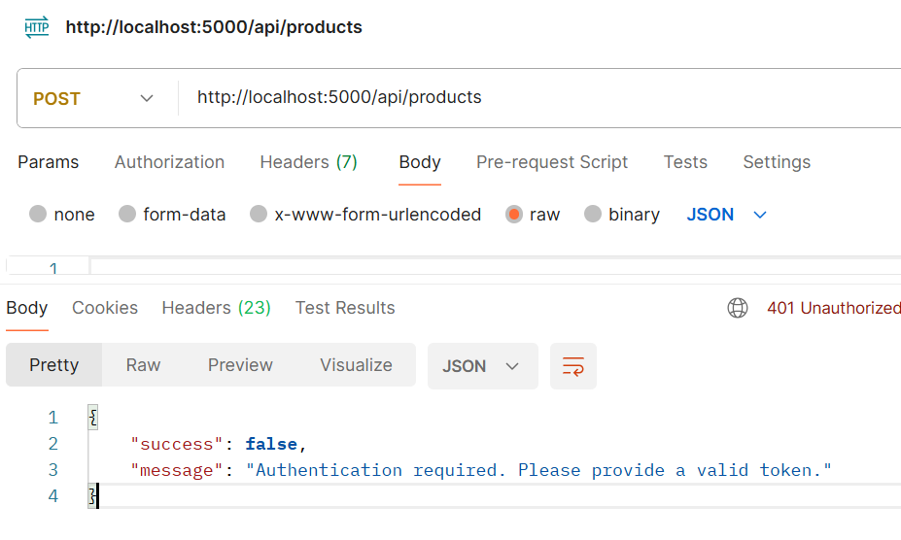
A product-creation request was sent without an authentication token to verify route protection. The API correctly rejected the request with a 401 Unauthorized status and a message indicating that a valid token is required, confirming that protected routes are properly secured against unauthenticated access.

Security & Validation Summary
The API incorporates multiple layers of protection to ensure data integrity and restrict access to authorized users only:
- Authentication: Protected routes require a valid JSON Web Token; requests without a token are rejected with a 401 Unauthorized response, as demonstrated in the Unauthorized Access test.
- Input Validation: Incoming data (product name length, category values, price, and stock) is validated on the server before being written to the database; invalid submissions return a 400 Bad Request response with detailed, field-level error messages.
- Consistent Response Structure: Every response — success or failure — follows a predictable JSON shape (success, message, data/errors), which makes the API easier to integrate with and debug.
- Error Transparency: Validation errors clearly identify the offending field and the reason for rejection, improving the developer/client experience without exposing sensitive internal details.

MongoDB Aggregation & Analytics Explanation
The /api/products/analytics endpoint is powered by the MongoDB Aggregation Framework rather than a simple find() query, allowing multiple statistics to be computed directly at the database level for better performance and scalability.
The aggregation pipeline groups the entire product collection to calculate an overview — total number of products, total stock across the catalog, minimum price, maximum price, and average price — and separately groups documents by the category field to produce a category-wise breakdown showing the product count, total stock, and average price within each category. Performing these calculations inside MongoDB (rather than fetching all documents and computing the values in application code) reduces network overhead and takes advantage of MongoDB’s native aggregation performance.

Conclusion
The Product Catalog Management API developed for Task 2 successfully fulfills all core requirements: secure authentication, complete CRUD functionality, flexible search and filtering, pagination, aggregation-based analytics, robust input validation, and route-level authorization. Each feature was individually tested through Postman, and the corresponding request/response evidence has been documented above to verify correct and consistent behavior across both successful and failure scenarios.
Overall, the testing confirms that the API is stable, secure, and ready for integration with a front-end application or further extension with additional catalog-management features.

